
Team Leader Year 5&6 Information & Application Pack

Advertisement
Scale A Teacher Team Leader Y5&6 – 2 Permanent Management Units

Our Year 5&6 Team Leader is heading off to the Ministry of Education! We seek a creative, critical, and curious team leader who loves learning with children. Effective use of digital technologies, Assessment for Learning practices, and growing future focussed learners is paramount. We are a well-resourced school that is respectful of your work and dedication. We have engaged and positive people who love learning. Our supportive community value school and learning. We nurture life-long learning and are committed to growing your resilience and independence. We are inclusive and value diversity. A great career opportunity leading a large team. We encourage you to visit us to see if we are the right place for you.

The terms and conditions, including base salary, for this position is set by the Primary Teachers' Collective Agreement. The base salary for trained and registered teachers will range from $65 685 to $105 663, depending on applicant’s qualifications and experience. Individual’s actual base salary will be established by a salary assessment once a role is confirmed. Permanent Management Units are at a rate of $5 100 (effective 2 Apr 2026).

Applications close 12pm Monday 12th November. Application packs are available via the school office phone 09 846 1359 or email executiveofficer@ptchev.school.nz or under Vacancies on www.ptchev.school.nz

Timeline

Position Advertised
- Online via Education Gazette Monday 25th May 2026
- School Website Monday 25th May 2026

Applications Close 10th June at 12.00pm
Short List Meeting 10th June
Short List Applicants Notified 10th June
Interviews from 12th June
Confirmation of Appointment 15th June
Anticipated start date 20th July 2026


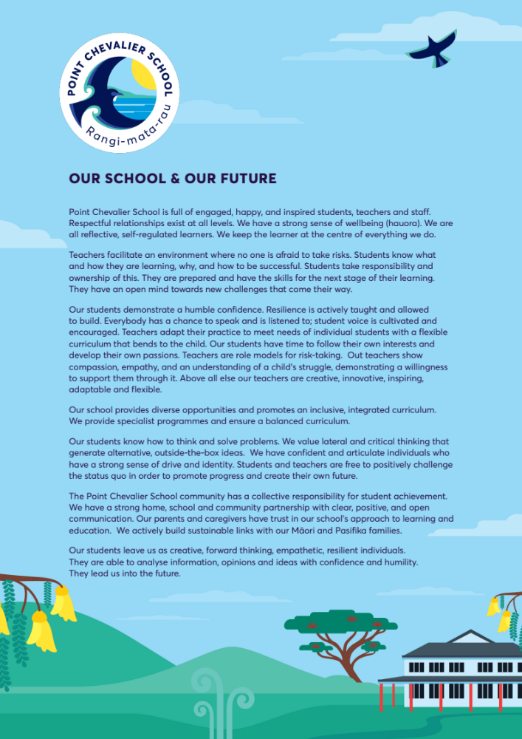

OUR SCHOOL

Point Chevalier School | Rangi-mata-rau is a large (U6) contributing Primary School. We will end 2026 with 667 students and a large staff of well over 50. The school has had stable and effective leadership for several years.

Our School is committed to supporting our staff as they are our most valuable and treasured resource.

Supporting your Work Environment
Our grounds are wonderful. We have many mature trees lining our boundaries, shading our play areas, creating a native tree grove.

Trees have been added in recent years. Thousands of dollars have been spent in developing garden areas, under-planting existing trees and landscaping for beauty. We are very proud of our grounds as there is a space and place for any activity.

We have thirty-two classrooms and a number of small teaching spaces. We have a 25-metre swimming pool, have a music room, an outdoor Tiger Turf floodlit covered court, and a recently completed multipurpose technology / kitchen facility. Our auditorium seats 720 people and is a valuable centre for many cultural and performing arts activities. Our library is the envy of many schools and houses our teaching resources. We have renovated our year 5&6 spaces ensuring we have a great learning environment for all.

We have a large staff lounge where people can relax and recharge. Te Whare Wānanga is where we meet as a staff once a week if needed. This is also a space for teacher release and learning.

We supply you with the tools of today so that you can work efficiently and effectively. We have numerous devices and will consolidate our approach to student owned devices each year. Each teacher has a laptop and an iPad supplied for their use.

Point Chevalier School | Rangi-mata-rau is well set up for learning and teaching.

Supporting your Health
Our School Board believes the staff is our greatest asset. Investing in quality staff is an investment in quality education. Having selected staff carefully, its next priority is to invest in the good health of that staff.

HIB, Hep. B, Measles and flu vaccines are fully funded or provided on site. We run an Employee Assistance Programme through Vitae – this is open to all members of staff and covers the cost of 3 counselling sessions.

We also provide staff jackets to keep you dry and warm – and no you don’t have to hand them back! We take your health seriously; we want you to be at your best.
Supporting Classroom Programmes
Each of our teachers belongs to one of six teams, with an appointed team leader. Each of our support staff belongs to a support staff team.

These teams meet regularly to plan team activities, classroom programmes, and grow their adaptive expertise.

Although each team is the ‘home base’ for support, the school has developed other very effective support structures. These include:
- A staffed school library and resource centre that supports teachers in everyday learning
- Te Reo Māori specialisation designed to help staff and students increase their understanding of Māori Language and Tikanga
- Music specialisation which allows teachers time for CRT, as well as professional development in Music on a regular basis
- A student support facility. Although your students are your responsibility, our staff in student support have the knowledge and willingness to help our teachers with GATE, CWSN, ESOL or behaviourally challenging children

Supporting Professional Learning
We grow and develop leaders and learners. As a school we set aside a generous professional learning budget for the staff as well as a separate budget for the leadership team.

Our focus is on deepening our Assessment for Learning practices and we have a commitment to collaborative inquiry using the Kaiser and Halbert model of Inquiry Spirals. We are a founding member of the New Zealand Network of Inquiry and Innovation (NZNoII) and attend local, national and international network events. Our Extended Leadership Team have regular mentoring and coaching. The Senior Leadership Team are here to grow your leadership and support your journey.

Supporting Tertiary Study
Our Board wishes to assist teachers to achieve their goals of advancing their qualifications and thus also increasing their own personal salaries. Our Board has therefore agreed to pay 50% of the cost of all tertiary papers that lead towards an education diploma or a degree. We are partnered with the University of Auckland in a Mentor relationship. This means that all course fees for our staff are half price – including Postgrad qualifications

We set aside a budget of up to $5,000 per year to assist our staff. In addition to this financial assistance, our Board offers one day’s study/exam leave per paper.

Support staff also need a high degree of training. To encourage this, where it is identified by the school leadership that a tertiary paper is necessary for the staff member to carry out the job, partial course fees may be granted to assist.

Supporting your Career
Everyone at Point Chevalier School | Rangi-mata-rau works hard to make this a quality school. We have a commitment to success in student achievement and staff career satisfaction.

This is important for every staff member. A staff member, who has worked in a school that is seen to be successful, has better career opportunities for the future. If one’s school is recognised as a leader, the teachers in that school are also likely to be recognised as leaders. While we hope our staff members will stay, we also hope that if they do leave they will go on to career advancement.

We are committed to providing opportunities to grow your capacity and hopefully provide you with challenge. There is a history of growing Team Leaders, Associate Principals and Principals at Point Chevalier School | Rangi-mata-rau.

In 2017 we worked with Dr John Edwards and Bill Martin in shaping the future of our school. This was a three-year commitment and the Senior Leadership Team was coached by one of the best leadership coaches around in Dr John Edwards.

Supporting your need to have Fun!
Yes, we do work hard and we take the education of our students seriously. That doesn’t mean we take ourselves too seriously. Our students and community love our sense of fun. That means that we need to build in fun – officially – like they do in some other workplaces. We shouldn’t always have to pay for that fun ourselves. This is what we do.

- Enjoy an end of year Christmas Lunch and drinks.
- All staff members enjoy an afternoon off at the end of each year (the classes double up) to go out to lunch or to do some shopping
- Enjoy team social dinners, coffees and other occasions
- Take part in the staff initiated cycling or walking groups
- Relax in the staff lounge – There is no work in the lounge!
- Enjoy Friday after school refreshment hours
- Staff games against the students
- Dress up Days
The list is not definitive or exhaustive – we welcome your ideas for fun. We have a staff of more than 50 people in total so there’s plenty of scope for the social dimension.

Supporting… You!
Ultimately, we want to support you. You need all these systems and structures so that you can work to the best of your ability. So that you can grow, so that you can feel safe making mistakes and learning.

We have a strong, supportive culture in which you can thrive.

PERSON SPECIFICATION

The primary concern for us is finding a special teacher and leader, capable of developing enriching and engaging programmes for the students in their class and team. The following dimensions serve to flesh out our mental models of a special person, yet are by no means a complete picture.

Teaching and Learning
- Is an effective teacher committed to fostering powerful learning for all, using Assessment for Learning capabilities and approaches.
- Demonstrates expertise and has refined strategies to enable all learners to access the curriculum in order to maximise learning.
- Effectively, efficiently and thoughtfully uses a wide range of resources from a variety of sources to support learning for students.
- Is committed to using formative assessment as a ‘backbone’ for all learning.
- Has an ability to inspire and motivate students to reach and exceed their potential.
- Is willing to enrich and extend students and allow them to take their learning to where they want to go.
- Shows creativity in teaching and is not afraid to experiment at the fringe.
- Has a commitment to working alongside other teachers.
- Strength in using technology in every day learning.

Students and Community
- Possesses a kids first attitude
- Fosters positive relationships between the school and all sectors of the community especially the new families starting school (NE) and existing families (Y5&6).
- Takes an interest in the wider corporate life of the school.
- Acknowledges the importance of student, parent and teacher working toward a common goal.
- Actively contributes to the greater good of the school.

Commitment to Personal Learning
- Loves learning.
- Relishes challenge and action learns your way through confusion.
- Understands that there are a number of ways of doing things
- Passionate about life long learning
- Has an interest or area of passion away from the school setting.
- Shows to all that learning is fun
- Understands that no matter what you know it is your walk that talks.
- Understands that not knowing is just as powerful as knowing.
- Embraces creativity
APPLICATION: Team Leader Year 5&6

This application form is to be completed and emailed with a letter of application and current curriculum vitae to:

Mr Stephen Lethbridge
c/o executiveofficer@ptchev.school.nz

Before 12:00pm on Wednesday 10th June 2026

Checklist…

Application form completed

Brief C.V enclosed (if you wish your CV to be returned enclose a stamped self-addressed envelope - CVs will be destroyed if SAE is not included)

Letter of Application enclosed (with the correct name of the school and principal)

Please Note

If shortlisted, you will be required to bring to your interview, originals of two types of identification. One from category A, one from Category B. You are also required to bring your Practising Teacher Certificate.

Category A | Category B
New Zealand Passport | New Zealand Driver’s Licence
A New Zealand Certificate of Identity issued under the Passports Act 1992 to Non-New Zealand citizens who cannot obtain a passport from their country of origin | 18+ Card (must be current)
New Zealand certificate of Identity (issued to people who have refugee status) | Community Services Card
New Zealand Refugee Travel Document | Super Gold Card
Emergency Travel Document | Veteran Super Gold Card
New Zealand Firearms License | Inland Revenue Number
Overseas Passport (with or without New Zealand Immigration Visa/Permit) | New Zealand issued utility bill, issued not more than 6 months earlier.
New Zealand Full Birth Certificate issued on or after 1998 | Electoral Roll Records

New Zealand Citizenship Certificate

INFORMATION FOR APPLICANTS

Thank you for applying for a position with our school. Please ensure you have the person specifications in mind when completing this application.

- Please complete this form personally. Read it through first then answer all questions and make sure you sign and date where indicated.

- Attach a brief curriculum vitae (CV) containing any additional information. If you include written references, please note that we may contact the writers of the references.

- We will return curriculum vitae (CV) only if you provide a stamped self-addressed envelope. CV’s will be destroyed 1 month after the appointment of the successful candidate.
- Copies only of qualification certificates should be attached. If successful in your application you will be required to provide originals as proof of qualifications. These will be needed to verify the copies which will be retained for the school’s records.
- If you are selected for an interview you may bring whānau/support people at your own expense. Please advise us if this is your intention.
- Failure to complete this application and answer all questions truthfully may result in any offer of employment being withdrawn or appointment being terminated if any information is later found to be false.
  - In terms of a Criminal Conviction, the Criminal Records (Clean Slate) Act 2004 provides certain convictions do not have to be disclosed providing:
    - You have not committed any offence within 7 (consecutive) years of being sentenced for the offence and
    - You did not serve a custodial sentence at any time (this would exclude serious offences such as murder, manslaughter, rape and causing serious bodily harm) and
    - The offence was not a specified offence (specified offences are in the main sexual in nature) and
    - You have paid any fine or costs

Please note that you are not obliged to disclose convictions if you are an eligible individual but can do so if you wish. If you are uncertain as to whether you are eligible contact the Ministry of Justice.

  - Under the Vulnerable Children Act 2017, core workers in schools will not be covered by the Clean Slate.
All serious sexual or violent offenses against children will be included in Police vetting results. The Act will make it unlawful to employ people with convictions for these offences, unless they have an exemption.

- This application form and supporting documents will be held by the school. You may access it in accordance with the provisions of the Privacy Act 2020.

- All information received will be confidential to the Appointments Committee of Point Chevalier School | Rangi-mata-rau.

If you have any queries, please contact the Principal of Point Chevalier School | Rangi-mata-rau.

 | Application for Team Leader Year 5&6
 | Teaching Level |  | Year 5&6
Personal Details | Surname
Personal Details | First Names  (in full, underline preferred)
Personal Details | Title |  | Mr Mrs Ms Miss Other (please state)
Personal Details | Postal Address
Personal Details | Phone Number (Day) |  |  |  |  |  |  | email
Personal Details | Phone Number (Evening)
Personal Details | NZ Registration Number |  |  |  |  |  |  | Certification Expiry Date
Personal Details | Ministry of Education Number
Current Employment | Name of Current Employer
Current Employment | Address
Current Employment | Phone |  |  |  |  |  |  |  | Mobile
Current Employment | Position Held
Current Employment | Date Commenced
Referees | Please provide the names of three people who could act as your referees. At least two of these should be able to attest to your work performance.
Referees | Name |  | Address |  |  |  |  | Phone |  |  |  | Relationship
Qualifications | Highest Secondary School Qualification
Qualifications | Tertiary Qualifications
Qualifications | Qualification |  |  |  | Date awarded |  |  |  |  |  | Institution
Employment History | Teaching Service
Employment History | Position |  | Salary Scale | School |  |  |  |  |  |  |  |  | Date From |  |  |  | Date To
Professional Memberships | Teachers understand the need to be connected Note: PRTs may not have formal memberships
Professional Memberships | Current Memberships / Networks |  |  |  |  | Past Memberships / Networks
The position you are seeking requires specific knowledge, skills, attributes and personal characteristics. These are stated in the person specification sheet in this application package. Please complete the following self-assessment. Please limit your responses to the space provided. Bullet points are acceptable.

If you have any questions about this section please contact the Principal, Mr Stephen Lethbridge.
 |  | Teaching and Learning
 |  | Students and Community
Self-Assessment
 |  | Commitment to Personal Learning

Be creative… This is your space
Your Space

 | The following information is collected for EEO statistical purposes only
Ethnic Identity | Please tick one or two boxes that most clearly describe you
Ethnic Identity | NZ European / Pakeha |  | Māori
Ethnic Identity | Samoan |  | Tongan
Ethnic Identity | Cook Island |  | Other Pasifika
Ethnic Identity | Asian Ethnicity |  | Please state
Ethnic Identity | Other European |  | Please state
Ethnic Identity | Other Ethnic Group |  | Please state

Other Information | Have you had any injury or medical condition which the tasks of this job may aggravate or contribute to, or know of any reason why you might have difficulty carrying out the job of a classroom teacher at Point Chevalier School?
Other Information | Yes No
Other Information | If yes, please give details below
Other Information | Do you have any matters relating to yourself currently or previously before the Education Council of Aotearoa New Zealand (EDUCANZ)? |  |  |  |  |  |  | Yes No
Other Information | Do you have a current New Zealand Driver License? |  |  |  |  |  |  | Yes No
Other Information | Do you give permission for your police record to be checked? |  |  |  |  |  |  | Yes No
Other Information | Are you a New Zealand Citizen |  |  |  |  |  |  | Yes No
Other Information |  |  | - If not, do you have residential status? |  |  |  |  | Yes No
Other Information |  |  | - and/or a current Work Visa |  |  |  |  | Yes No
Other Information | Have you changed your name by deed poll / statutory declaration? |  |  |  |  |  |  | Yes No
Other Information | If yes, other names known by:
Privacy Act 2020 | TO BE SIGNED BY THE APPLICANT  This Application is submitted with the understanding that any further information given is for the use of the employer and their authorised representatives who may at any time have access to this information.  Furthermore, consent is given for members of the Point Chevalier School | Rangi-mata-rau Appointments Committee or its advisor to make enquiries of my present or past employers or colleagues or any other person who may assist in establishing my suitability for the position of Team Leader at this school including accessing any information used by the Teaching Council of Aotearoa New Zealand
Privacy Act 2020 | Applicant’s Signature |  |  | Date
Declaration | HAVE YOU EVER BEEN CONVICTED OF AN OFFENCE AGAINST THE LAW? (Apart from minor traffic offences). Have you received police diversion for an offence, have charges pending or know of any reason why you should not be employed to work in a school environment?
Declaration | Yes No
Declaration | If YES, please provide date and details of offence(s) on a separate sheet. Please note that you may be asked to provide a copy of the relevant court records available from the registrar of the court concerned.  I certify that I know of no reason why I would not be suitable to work with children/young people.  I certify that I am registered (or provisionally registered) as a New Zealand teacher. I solemnly and sincerely declare that to the best of my knowledge and belief the information given in this application and in my C.V. is correct.
Declaration | Applicant’s Signature |  |  |  | Date

